**Assembly Homework Ch 3**

**Your Name:謝豐安 Student ID (學號):V1055548**

1. Print your executing results 20% (貼上執行結果20%)

Problem1-modify1

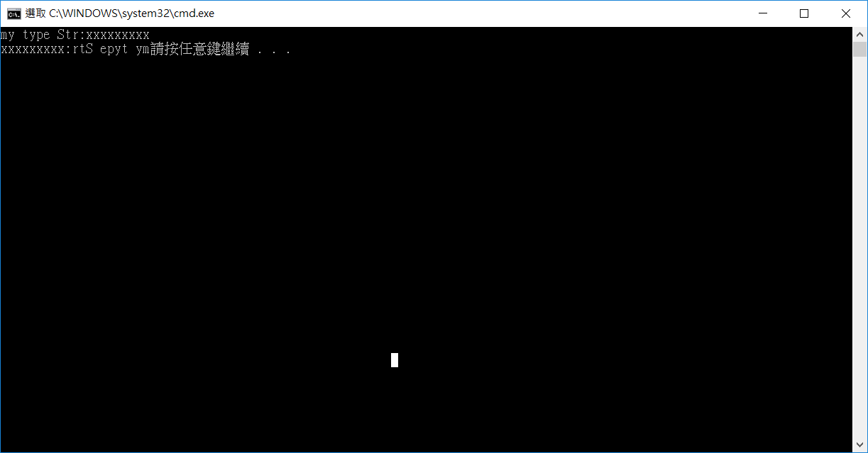

2. Source Code 20% and Comments 60% (程式原始碼20%與程式註解說明50%)

INCLUDE Irvine32.inc

; Reversing a String (RevStr.asm)

; This program reverses a string.

.386

.model flat,stdcall

.stack 4096

ExitProcess proto,dwExitCode:dword

.data

aName BYTE 50 DUP('?'),0 ;biggest size is 50 bytes

nameSize DWORD ? ;

.code

main proc

mov ecx , 50 ;move biggest chars to ecx

mov edx , offset aName ;move the address of aName to edx

call ReadString

call StrLength ;eax=length of edx

mov nameSize , eax ;move eax to nameSize

mov ecx , nameSize ;move nameSize to ecx(counter)

mov esi , 0 ;move 0 to esi

L1:

movzx eax , aName[esi] ; move each aName char to eax

push eax ;push eax to top of stack

inc esi ;increase esi

loop L1

mov ecx , nameSize ;move nameSize to ecx(counter)

mov esi , 0 ;move 0 to esi

L2:

pop eax ;pop the top of stack to eax

mov aName[esi] , al ;move al to aName[esi]

inc esi ;increase esi

loop L2

mov edx , offset aName ;move the address of aName to edx

call WriteString ;writestring

Invoke ExitProcess,0

main endp

end main

1. Print your executing results 20% (貼上執行結果20%)

Problem1-modify2

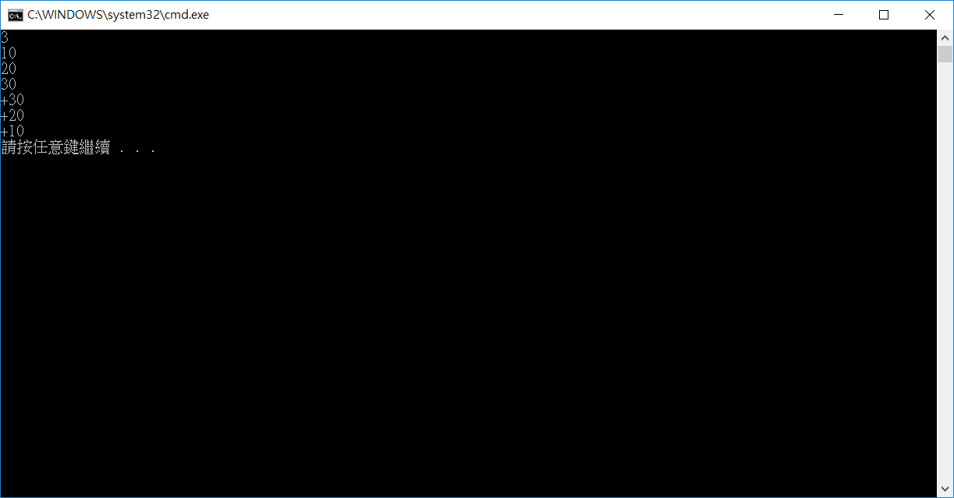

2. Source Code 20% and Comments 60% (程式原始碼20%與程式註解說明50%)

INCLUDE Irvine32.inc

; Reversing a String (RevStr.asm)

; This program reverses a string.

.386

.model flat,stdcall

.stack 4096

ExitProcess proto,dwExitCode:dword

.data

inp DWORD 0 ;store the number of inputs

.code

main proc

call ReadInt ;read int

mov inp , eax ;move number of inputs to inp

mov ecx , inp ;move number of inputs to ecx register

L1:

Call ReadInt ;read int

push eax ;push to stack

loop L1

mov ecx , inp ;move again to ecx

L2:

pop eax ;pop top value to eax

call WriteInt ; print to screen

call crlf ;change line

loop L2

Invoke ExitProcess,0

main endp

end main

1. Print your executing results 20% (貼上執行結果20%)

Problem2

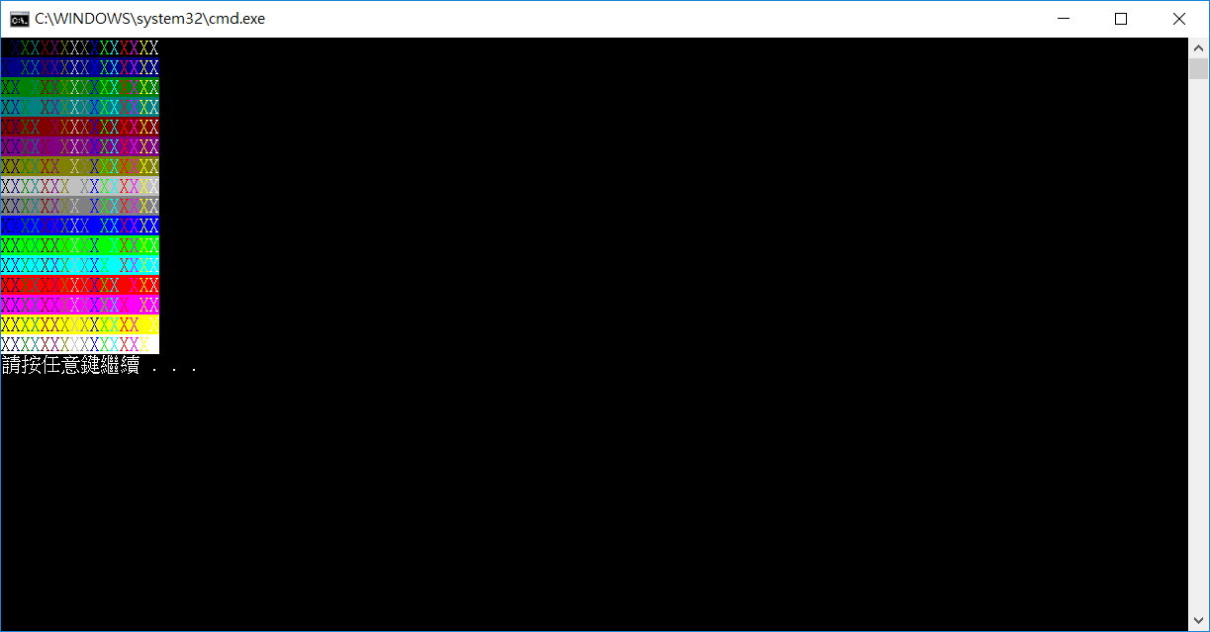

2. Source Code 20% and Comments 60% (程式原始碼20%與程式註解說明50%)

INCLUDE Irvine32.inc

; Reversing a String (RevStr.asm)

; This program reverses a string.

.386

.model flat,stdcall

.stack 4096

ExitProcess proto,dwExitCode:dword

.data

str1 BYTE "X",0 ;printed by following code

Temp DWORD ? ;Being used to store L1 loop counter

.code

main proc

mov ecx , 16 ;initial counter for L1

mov ebx , 0 ;use to show color

mov edx , offset str1 ;move the address of str1 to edx

L1:

mov Temp , ecx ;store L1 counter

mov ecx , 16 ;assign L2 counter value

L2:

mov eax ,ebx ;move the color value to eax(ebx)

inc ebx ;increase ebx to show next color

call SetTextColor

call WriteString

loop L2

call crlf

mov ecx , Temp ;back the value of L1 counter

loop L1

mov eax,15 ; set color to initial color

call SetTextColor

Invoke ExitProcess,0

main endp

end main

1. Print your executing results 20% (貼上執行結果20%)

Problem3

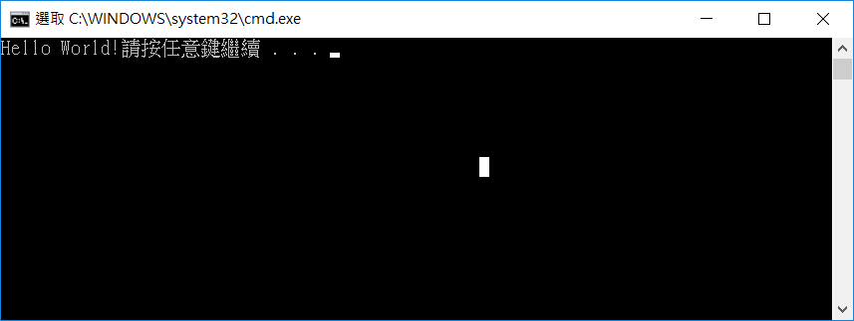

2. Source Code 20% and Comments 60% (程式原始碼20%與程式註解說明50%)

INCLUDE Irvine32.inc

; Reversing a String (RevStr.asm)

; This program reverses a string.

.386

.model flat,stdcall

.stack 4096

ExitProcess proto,dwExitCode:dword

.code

main proc

call CMYSTRING

Invoke ExitProcess,0

main endp

end main